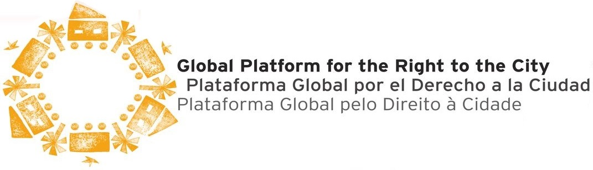
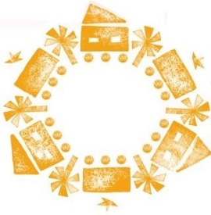

GPR2C STATEMENT ON CORE MESSAGES FOR HABITAT III IN THE
Habitat III Europe Regional Meeting Prague March 18 2016
In the context of the preparatory process towards the 3rd UN Conference on Housing and Sustainable Human Settlements (Habitat III, Quito, October 2016) and inspired by the occasion of Habitat III Europe Regional Meeting Prague, we launch a strong call for the inclusion of the Right to the City as the cornerstone of the New Urban Agenda and of the responsibility of all the actors for its implementation. In order to do that, it is essential to ensure the participation of civil society organizations and local governments - on equal basis with respect to the other actors - as key partners in the definition and implementation of the New Urban Agenda.
It is essential that the whole process and methods include the participation of civil society organizations and local governments to be able to address the diversity of interests and practices. Therefore, we call for that this international effort recognizes innovations by these actors in order to achieve more just, democratic and sustainable cities in which human rights are fulfilled as well as their responsibility towards the future generations. The Global Platform is advocating for a Habitat III outcome to embrace the Right to the City Principles across the next core domains:
The City as a common good contains the following components:

- A city free of discrimination based on gender, age, health status, income, nationality, ethnicity, migratory condition, or political, religious or sexual orientation.
- A city of inclusive citizenship in which all inhabitants, whether permanent or transitional, are considered as citizens and granted equal rights; e.g. women, those living in poverty or situations of environmental risk, informal economy workers, ethnic and religious groups, LGBT persons, the differently abled, children, youth, the elderly, migrants, refugees, street dwellers, victims of violence and indigenous peoples.
- A city with enhanced political participation in the definition, implementation, monitoring, and budgeting of urban policies and spatial planning in order to strengthen the transparency, effectiveness and inclusion of the diversity of inhabitants and their organizations.
- A city fulfilling its social functions, that is, ensuring equitable access for all to shelter, goods, services and urban opportunities, particularly for women and other marginalized groups; a city that prioritizes the collectively defined public interest, ensuring a socially just and environmentally balanced use of urban and rural spaces.
- A city with quality public spaces that enhances social interactions and political participation, promotes socio-cultural expressions, embraces diversity, and fosters social cohesion; a city where public spaces contribute to building safer cities and to meeting the needs of inhabitants.
- A city of gender equality which adopts all necessary measures to combat discrimination in all its forms against women, men, and LGBT people in political, social, economic and cultural terms; a city which takes all appropriate measures to ensure the full development of women, to guarantee them equality in the exercise and fulfillment of fundamental human rights, and a life free of violence.
- A city with cultural diversity, which respects, protects, and promotes the diverse livelihoods, customs, memory, identities, expressions, and socio-cultural forms of its inhabitants.
- A city with inclusive economies that ensures access to secure livelihoods and decent work for all inhabitants, that gives room to other economies, such as solidarity economy, sharing economy, circular economy, and that acknowledges the role of women in the care economy.
- A city as a system within the settlement and common ecosystem that respects rural-urban linkages, and protects biodiversity, natural habitats, and surrounding ecosystems, and supports city-regions, city-town cooperation, and connectivity.

Measures to implement the Right to the City
- Protect, promote and implement the Right to the City in all Habitat III documents;
- Enshrine new paradigms for integrated planning and management in the New Urban Agenda;
- Ensure inclusive, democratic, secure and sustainable cities;
- Fulfill the social function of property by strengthening collective social, cultural and environmental interests over individual and economic interests;
- Incorporate the priorities, needs and experiences of citizens and communities, especially for women, the poor, the minorities and vulnerable groups, and the organizations supporting them.
- Produce an outcome document with specific and measurable results and commitments
- Ensure access to basic and social services, mobility, public and green spaces and the enjoyment of natural and built heritage.
- Produce an outcome document with specific and measurable commitments and results on the implementation of the various components of the Right to the city as well as of the new Sustainable Development Goals.
Role of local governments
- Ensure full participation of local governments in the Habitat III process with their role reflected in outcome documents;
- Recognize local governments as crucial actors in the Habitat III outcomes, requiring the means for effective public management and citizen participation, to preserve cities as commons;
- Recognize the central role and responsibility of local government in the promotion, protection and guarantee of human rights and the adoption of Human Rights Charters ;
- Recognize the right to a city constituted as a local political community that ensures adequate living conditions and peaceful coexistence between peoples and with government;
- Implement real decentralization with the necessary competencies and resources, to ensure that local governments can take effective decisions to fulfill inhabitants' rights;
- Ensure that all city inhabitants have rights to participate in political and city management processes and create conditions for citizens empowerment;
- Recognize local authorities as key to a safe, secure and sustainable urban future;
- Enshrine local fiscal systems that generate people-centred outcomes: fair local taxation and equitable sharing of national and international resources.
Housing and secure tenure
- Protect, promote and implement the Right to housing in all Habitat III documents;
- Prioritize secure tenure rights to land and housing as a keystone of the New Urban Agenda;
- Enshrine the right to adequate housing in all legal, policy and delivery frameworks;
- Control market-led speculation and protect people and communities from forced evictions, displacements and land-grabbing;
- Promote inclusive, community-led approaches to the production of habitat;
- Promote slum upgrading and risk prevention, prioritizing the security of tenure and the respect of all human rights;
- Ensure public means and support for housing production;
- Create a legal framework to ensure public land value capture operations for the inclusion of the poor and marginalized people.
- Promote explicit subsidies for female headed households under poverty line and with children under their sole responsibility.

Jobs and livelihoods
- Enshrine the right to secure and decent livelihoods in all Habitat III documents;
- Ensure legal protection of workers, including the right to decent work, to organize, and freedom from discrimination;
- Promote inclusive economic growth and solidarity- based and collaborative economy, that reduces vulnerability, strengthen livelihoods, narrows gender equity gaps, and prioritizes health and safety;
- Encourage the creation of solidarity- based income for the more vulnerable and act towards universal basic income
- Recognize informal economy workers as legitimate economic agents;
- Include workers in the decision-making and planning of cities.
- Recognize the private and public work assumed by women in general which implies a double and triple burden under their responsibilities, particularly when alone responsible of their households.
The Global Platform for the Right to the City is an international network supported by over 100 civil society organizations, social movements, academic institutions, local governments, public sector agencies, foundations and international organizations, which seeks to create an international movement to campaign for the recognition and implementation of the Right to the City at local, national and global level.
TheGPR2C support the concept and definition of Right to the City in the Policy Unit 1 – Habitat III is thus defined as the right of all inhabitants present and future, to occupy, use and produce just, inclusive and sustainable cities, defined as a common good essential to the quality of life. The Right to the City further implies responsibilities on governments and people to claim, defend, and promote this right. The Right to the City as a diffuse right can be exercised in every metropolis, city, village, or town that is institutionally organized as local administrative unit with district, municipal or metropolitan character. It includes the urban space as well as the rural or semi-rural surroundings that form part of its territory.

PLATFORM PARTNERS include …ActionAid, Brazilian National Urban Reform Forum(Brazil), Cities Alliance, Fundación Avina, Global Fund for the Development of Cities (FMDV), Habitat International Coalition (HIC), Habitat for Humanity, International Alliance of Inhabitants (IAI), Polis Institute, Shack/Slum Dwellers International (SDI), StreetNet International, UCLG Committee on Social Inclusion, Participatory Democracy and Human Rights, Women in Informal Employment: Globalizing and Organizing (WIEGO), Women and Habitat LAC Network, RIPLESS, TETO,Huairou Commission.

